Tramper Price List – 01/02/2023

Product Retail Price
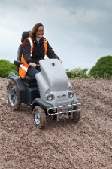

Tramper MkII S £8150.00

Options & Accessories Retail Price

Wheel chair/Zimmer frame carrier £185.00

Cane and crutch holder £73.00

Tramper rear box £162.00

Trailer hitch £14.00

Flashing beacon £129.00

Waterproof cover £107.00

Auxiliary twist grip with changeover switch £163.00

Dog tie down point £9.00

Foot plate extension per side £78.00

Twist grip extension £14.00

Swivel seat base £200.00

12 volt power supply £210.00

Tramper bullbar £135.00

Note wheelchair carrier and box are mutually exclusive

All prices are quoted in UK £. All Prices quoted exempt of carriage and VAT E&EO

There will be a carriage charge on items bought after the initial sale
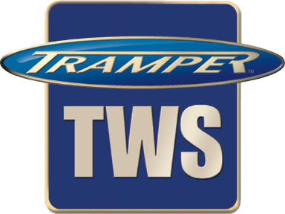
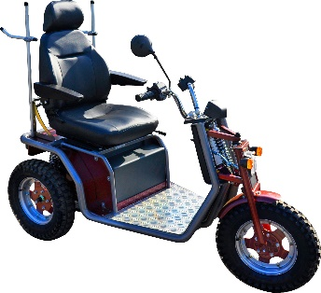
Tramper TWS 'KrystalClass III' – Price List
High mobility three wheeled class 3 scooter
with road traffic lights and a horn fitted £6500.00

Options Retail Price
Colour Silver and burgundy No cost option
Nato green No cost option
Silver and deep bronze green No cost option

Speed 4mph No cost option
6mph No cost option
8mph £168.00

Tyre Road/turf tyre £135.00
Medium off road Standard
Aggressive off road £180.00

Seat Basic non-adjustable Standard
High back with head rest seat slides
and back rake adjustment £157.00

Accessories Cane and crutch holder per side
(single stick holder) £36.50
Trailer hitch £68.00
Auxiliary twist grip with changeover switch £163.00
Dog Tie down point £9.00
12 V 8 amp power supply outlet £90.00
Twist grip extension £14.00
Rear accessory frame (needed for following options) £67.00
Wheelchair/ walking frame carrier £185.00
Lockable rear box £162.00
Flashing beacon £129.00
Note wheelchair carrier and box are mutually exclusive
Waterproof cover £107.00
Foot Support £157.00
Twist grip extension £14.00
Swivel seat base £210.00

All prices are quoted in UK £. All Prices quoted exempt of carriage and VAT
There will be a carriage charge on items bought after the initial sale
E&EO
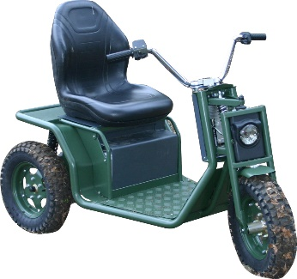
Tramper TWS Krystal'Utility' – Price List

High mobility three wheeled utility vehicle for use where it will only be used on private ground, with no road use, this is fitted with no road traffic lights just a head light and horn THIS IS NOT A CLASS 3 SCOOTER rather a silent, non-polluting, high mobility, utility vehicle, used for industrial or agricultural applications £6150.00

Options Retail Price
Colour Matt deep bronze green Standard
Other colours to order

Speed 4mph No cost option
6mph No cost option
8mph £168.00

Tyre Road/turf tyre £135.00
Medium off road Standard
Aggressive off road £180.00

Seat Basic non-adjustable Standard
High back with head rest seat slides
and back rake adjustment £157.00

Accessories No frame needed for;
Cane and crutch holder each £36.50
Trailer hitch £68.00
Auxiliary twist grip with changeover switch £163.00
12 V 8 amp power supply outlet £210.00
Twist grip extension £14.00
Rear accessory frame needed for; £67.00
Wheelchair/ walking frame carrier £185.00
Lockable rear box £162.00

n.b. with these options only one frame is needed
However these two items above are mutually exclusive

All prices are quoted in UK £. All Prices quoted exempt of carriage and VAT There will be a carriage charge on items bought after the initial sale E&EO

