Tramper Price List – 26/10/2021

Product Retail Price
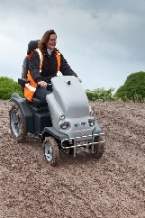

Tramper MkII Krystal £7200

Options & Accessories Retail Price

Trailer £1250.00
Wheel chair/Zimmer frame carrier £165.00

Cane and crutch holder £65.00

Tramper rear box £145.00

Trailer hitch £12.00

Flashing beacon £115.00

Waterproof cover £95.00

Auxiliary twist grip with changeover switch £145.00

Dog tie down point £8.00

Foot plate extension per side £70.00

Twist grip extension £12.00

Swivel seat base £160.00

12 volt power supply £185.00

Tramper bullbar £120.00

Lithium Battery Pack Upgrade 1560.00

Note wheelchair carrier and box are mutually exclusive

All prices are quoted in UK £. All Prices quoted exempt of carriage and VAT E&EO

There will be a carriage charge on items bought after the initial sale
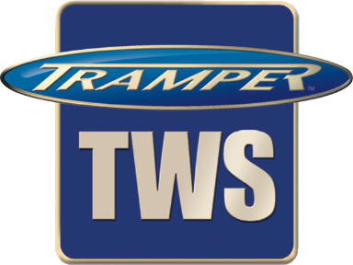
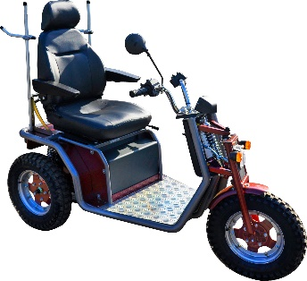
Tramper TWS 'KrystalClass III' – Price List
High mobility three wheeled class 3 scooter
with road traffic lights and a horn fitted £5860

Options Retail Price
Colour Silver and burgundy No cost option
Nato green No cost option
Silver and deep bronze green No cost option

Speed 4mph No cost option
6mph No cost option
8mph £150

Tyre Road/turf tyre £120
Medium off road Standard
Aggressive off road £160

Seat Basic non-adjustable Standard
High back with head rest seat slides
and back rake adjustment £140

Accessories Cane and crutch holder per side
(single stick holder) £32.50
Trailer hitch £60
Auxiliary twist grip with changeover switch £145
Dog Tie down point £8
12 V 8 amp power supply outlet £80
Twist grip extension £12
Rear accessory frame (needed for following options) £60
Wheelchair/ walking frame carrier £165
Lockable rear box £145
Flashing beacon £115
Note wheelchair carrier and box are mutually exclusive
Waterproof cover £95
Foot Support £140
Twist grip extension £12
Swivel seat base £160
Trailer £1250
Lithium Battery pack upgrade £1940

All prices are quoted in UK £. All Prices quoted exempt of carriage and VAT
There will be a carriage charge on items bought after the initial sale
E&EO
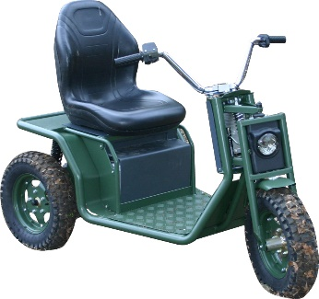
Tramper TWS Krystal'Utility' – Price List

High mobility three wheeled utility vehicle for use where it will only be used on private ground, with no road use, this is fitted with no road traffic lights just a head light and horn THIS IS NOT A CLASS 3 SCOOTER rather a silent, non-polluting, high mobility, utility vehicle, used for industrial or agricultural applications £5300

Options Retail Price
Colour Matt deep bronze green Standard
Other colours to order

Speed 4mph No cost option
6mph No cost option
8mph £150

Tyre Road/turf tyre £120
Medium off road Standard
Aggressive off road £160

Seat Basic non-adjustable Standard
High back with head rest seat slides
and back rake adjustment £140

Accessories No frame needed for;
Cane and crutch holder £60
Trailer £1250 Trailer hitch £60
Auxiliary twist grip with changeover switch £145
12 V 8 amp power supply outlet £185
Twist grip extension £12
Rear accessory frame needed for; £60
Wheelchair/ walking frame carrier £165
Lockable rear box £145
Lithium battery pack upgrade £1940

n.b. with these options only one frame is needed
However these two items above are mutually exclusive

All prices are quoted in UK £. All Prices quoted exempt of carriage and VAT There will be a carriage charge on items bought after the initial sale E&EO

